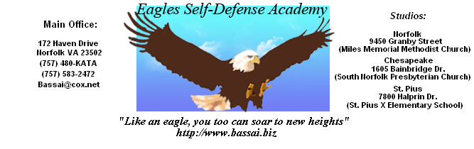

 |  | COLOR |  |  |  |  |  |  |  |  |  |  | Phone# | Remarks
NAME | QTY | White | Black | Red | Blue | Forrest Green | Green | Pink | Purple | Deep Purple | Gold | Burnt Orange
TOTAL

