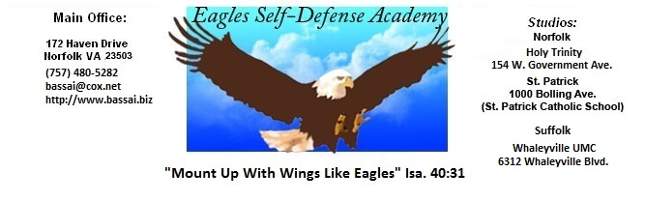

LEGEND: P+ = EXCEPTIONAL, P = ABOVE AVERAGE, P- = BELOW AVERAGE

EAGLES NAME: _____________________
SELF-DEFENSE ACADEMY DATE: ___ AGE: ____ BELT SIZE: _
INSTRUCTOR:

Adult 5th Blue Belt
Junior 4th Green
Test Requirements
REMARKS
I HOUR REQUIREMENTS: 40 - 60 Hours MINIMUM

II CLEAN UNIFORM WITH SCHOOL PATCH, FLAG
& PROPERLY TIED BELT

III FALLS & ROLLS
A. Forward Fall C. Forward Shoulder Roll E. Side Fall
B. Backward Fall D. Backward Shoulder Roll
IV STANCES (Forward and Backward)
A. Ready Stance D. Forward Stance
B. Straddle Leg Stance E. Side Stance
C. Back Stance F. Fighting Stance:
V COMBINATION FOOTWORK
A. Slide up, Reg., C. Slide Up - Step Thru F. Lunge- Slide Up
Skipping D. Step Thru - Lunge G. Lunge- Step Thru
B. Slide Up - Lunge E. Step Thru - Slide Up
VI PUNCHES & HAND STRIKES
Forward and Backward in Combination
VII CHOPS
Forward and Backward in Combination
VIII ELBOWS
Forward and Backward in Combination

IX BLOCKS
Forward and Backward in Combination

X ADVANCED BLOCKS
Forward and Backward in Combination

XI ALL BASIC AND ADVANCED KICKS ACROSS MAT IN COMBINATION (DOUBLE KICKS)
A. Standing Front A. Slide-up Front A. Stepping Front A. Lunging Front A. Skipping Front
B. Standing Round B. Slide-up Round B. Spinning Round B. Lunging Round B. Skipping Round
C. Standing Back C. Slide-up Back C. Spinning Back C. Lunging Back C. Skipping Back
D. Standing Side D. Slide-up Side D. Spinning Side D. Lunging Side D. Skipping Side
E. Standing Ax (Inside & Outside) E. Slide-Up Ax Kick E. Step-Thru Ax Kick
F. Standing Snapping Heel Kick F. Slide-Up Snapping Heel F. Step-Thru Snapping Heel
F. Spinning Heel Kick
G.Standing Crescent Kicks (Inside & Outside)

XII ONE STEP PUNCHING
.A. 2 Right Hand Attacks
B. 2 Left Hand Attacks.

XIII ATTACKING TECHNIQUES (WITH OR WITHOUT A PARTNER)

HANDS
A. Jab Slide Up, Reverse Punch, Step Reverse Punch
B. Jab Slide Up, Reverse Punch, Step Thru Back Knuckle, Reverse Punch
C. Jab, Reverse Punch, Step Thru Spinning Bottom Fist, Reverse Punch.
D. Lunging Jab, Reverse Punch
E. One Step Triple Punch (Jab,Reverse Punch, Step Reverse Punch)
F. Reverse Punch, Step Reverse Punch
G. Reverse Punch, Slide Up Jab, Reverse Punch

XIV SELF DEFENSE (4)

A. C.

B. D.

XV JUMP KICKS
A. Front Kick (One Step/Fake) L R C. Flying Side (One Step) L R
B. One Step Jump Spinning Round L R D. One Step Jump Spinning Side L R

XVI FORMS
Basic Form #1 Geicho Hyung Il Bu
Basic Form #1 Advanced Geicho Hyung Il Bu Sahn Gup
Basic Form #2 Geicho Hyung Yi Bu
Basic Form #2 Advanced Geicho Hyung Yi Bu Sahn Gup
Basic Form #3 Geicho Hyung Sahm Bu

XVII FREE FIGHTING
1 Two minute round. Head contact will result in a warning. The second time will result in test failure.
A. Variety of hand & feet Combinations C. Blocking & Side Stepping
B. Fakes

XVIII BREAKING (2 Power Breaks)

XVII ATTITUDE

