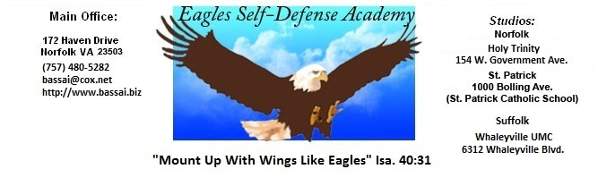

GEICHO HYUNG YI BU SAHN GUP
(BASIC FORM NR. 2 ADVANCED)

ALWAYS START YOUR KATAs IN A READY STANCE

SET 1
Look over left shoulder
Fold for left hand low block (two hand fold)
Step straight back with left foot.
Pivot to the left (1/4 turn)
Low block with left hand
Raise left hand to center
Stepping front kick with right leg. Land in a right foot forward stance.
High punch with right hand.

SET 2
Look over right shoulder
Fold for right hand low block (two hand fold)
Step straight back and across with right foot
Pivot to the right (1/2 turn)
Low block with right hand
Raise right hand to center
Stepping front kick with left leg. Land in a left foot forward stance.
High punch with left hand.

SET 3
Look over left shoulder
Fold for left hand low block (two hand fold)
Step straight back with left foot into a back stande (turn foot 90 degrees to left)
while right foot remains stationary)
Low block with left hand. Remain in a back stance.
In place reverse punch (right hand). Full hip action
Fold right hand for an inside block.
Step forward with your right foot, landing in a back stance.
Inside block. Remain in back stance.
In place reverse punch (left hand). Full hip action.
Fold left hand for a high block.
Step forward with your left foot, landing in a back stance.
High block. Remain in a back stance.
In place reverse punch (right hand). Full hip action.
Fold right hand for an outside block.
Step forward with your right foot, landing in a back stance.
Outside block. Remain in back stance.
In place reverse punch (left hand). Full hip action - KIAI

SET 4
Look over left shoulder
Fold for left hand low block (two hand block)
Step straight back with left foot (you should be in a right foot forward stance). Pivot
90 degrees to the left on balls of both feet (you should be in a left foot forward
stance). Step straight back with left foot. Turn left foot 90 degrees to left
while right foot remains stationary.
Low block with left hand (remain in back stance)
Raise left hand to center
Stepping front kick with right leg. Land in a right leg forward stance.
High punch with right hand.
SET 5
Look over right shoulder
Fold for right hand low block (two hand fold)
Step straight back and across with right foot
Pivot to the right (1/2 turn)
Low block with right hand
Raise right hand to center
Stepping front kick with left leg. Land in a left foot forward stance.
High punch with left hand.

SET 6
Look over left shoulder
Fold for left hand low block (two hand fold)
Step straight back with left foot into a back stande (turn foot 90 degrees to left)
while right foot remains stationary)
Low block with left hand. Remain in a back stance.
In place reverse punch (right hand). Full hip action
Fold right hand for an inside block.
Step forward with your right foot, landing in a back stance.
Inside block. Remain in back stance.
In place reverse punch (left hand). Full hip action.
Fold left hand for a high block.
Step forward with your left foot, landing in a back stance.
High block. Remain in a back stance.
In place reverse punch (right hand). Full hip action.
Fold right hand for an outside block.
Step forward with your right foot, landing in a back stance.
Outside block. Remain in back stance.
In place reverse punch (left hand). Full hip action – KIAI

SET 7
Look over left shoulder
Fold for left hand low block (two hand block)
Step straight back with left foot (you should be in a right foot forward stance). Pivot
90 degrees to the left on balls of both feet (you should be in a left foot forward
stance). Step straight back with left foot. Turn left foot 90 degrees to left
while right foot remains stationary.
Low block with left hand (remain in back stance)
Raise left hand to center
Stepping front kick with right leg. Land in a right leg forward stance.

High punch with right hand.

SET 8
Look over right shoulder
Fold for right hand low block (two hand fold)
Step straight back and across with right foot
Pivot to the right (1/2 turn)
Low block with right hand
Raise right hand to center
Stepping front kick with left leg. Land in a left foot forward stance.
High punch with left hand.

RETURN TO READY STANCE (PARRO) ON COMMAND ONLY

