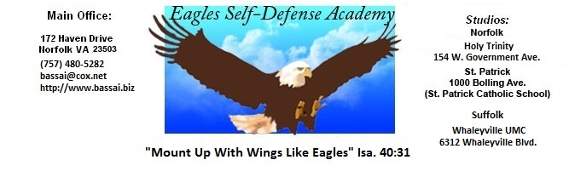

GEICHO HYUNG YI BU
(BASIC FORM NR. 2)

ALWAYS START YOUR KATAs IN A READY STANCE

SET 1
Look over left shoulder
Fold for left hand low block (two hand fold)
Step straight back with left foot
Pivot to the left (1/4 turn)
Low block with left hand
Raise left hand to center
Stepping high punch (step, land, punch) with right hand. Land in a right foot
forward stance
SET 2
Look over right shoulder
Fold for right hand low block (two hand fold)
Step straight back and across with right foot
Pivot to the right (1/2 turn)
Low block with right hand
Raise right hand to center
Stepping high punch (step, land, punch) with left hand. Land in a left foot forward stance

SET 3
Look over left shoulder
Fold for left hand low block (two hand fold)
Step straight back with left foot
Pivot to the left (1/4 turn)
Low block with left hand. Full hip action
Fold right hand for inside block.
Step forward with right foot. Inside block. Snapping hip action.
Turn right foot to the right 90 degrees.
Fold left hand for a high block.
Step forward with left foot. High block. Full hip action.
Turn left foot to the left 90 degrees.
Fold right hand for an outside block.
Step forward with right foot. Outside block. Full hip action. - KIAI
SET 4
Look over left shoulder
Fold for left hand low block (two hand block)
Pivot body 135 degrees, then step straight back and pivot the body the remaining 135 degrees for a total of 270 (3/4 turn)
Low block with left hand
Raise left hand to center
Stepping high punch (step, land, punch) with right hand. Land in a right foot forward stance.
SET 5
Look over right shoulder
Fold for right hand low block (two hand fold)
Step straight back and across with right foot
Pivot to the right (1/2 turn)
Low block with right hand
Raise right hand to center
Stepping high punch (step, land, punch) with left hand. Land in a left foot forward stance.

SET 6
Look over left shoulder
Fold for left hand low block (two hand fold)
Step straight back with left foot
Pivot to the left (1/4 turn)
Low block with left hand. Full hip action
Fold right hand for inside block.
Step forward with right foot. Inside block. Snapping hip action.
Turn right foot to the right 90 degrees.
Fold left hand for a high block.
Step forward with left foot. High block. Full hip action.
Turn left foot to the left 90 degrees.
Fold right hand for an outside block.
Step forward with right foot. Outside block. Full hip action. - KIAI
SET 7
Look over left shoulder
Fold for left hand low block (two hand fold)
Pivot body to the left 135 degrees, then step straight back and pivot the remaining 135 degrees for a total of 270 (3/4 turn)
Low block with left hand
Raise left hand to center
Stepping high punch (step, land, punch) with right hand. Land in a right foot forward stance.
SET 8
Look over right shoulder
Fold for right hand low block (two hand fold)
Step straight back and across with right foot
Pivot to the right (1/2 turn)
Low block
Raise right hand to center
Stepping high punch (step, land, punch) with left hand. Land in a left leg
forward stance.

RETURN TO READY STANCE (PARRO) ON COMMAND ONLY

