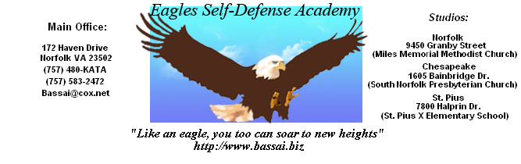

 |  | COLOR |  |  |  |  |  |  |  |  |  |  |  | Phone #
NAME | QTY | Ash | Light Steel | White | Light Blue | Gold | Forest Green | Black | Deep Red | Royal | Cardinal | Navy | Deep Navy

