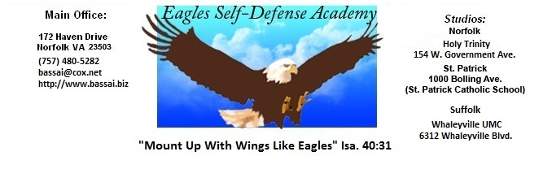

LEGEND: P+ = EXCEPTIONAL, P = ABOVE AVERAGE, P- = BELOW AVERAGE

EAGLES NAME: _____________
SELF-DEFENSE ACADEMY DATE: AGE: ____
BELT SIZE: _____
INSTRUCTOR:

Adult Orange
Junior 6th Blue Belt
Test Requirements

REMARKS
I HOUR REQUIREMENTS: 40 - 60 Hours MINIMUM

II CLEAN UNIFORM WITH SCHOOL PATCH, FLAG
& PROPERLY TIED BELT

III TERMS
A. Karate (Car Ah Tea) - Empty hand H. Sho (Show) - Relax
__B. Tang Soo Do (Tah_ng Sue Doe) - Art of the hands I. Do Jang (Doe Jah_ng) - Karate Studio
Charyut (Carry Ut) - Attention. J. Sho (Show) - Relax
D. Kyung Ne (Key_Young Knee) - Bow K. Gup - Rank below Black Belt
E. Toe Bok (Toe Bok) - Karate Uniform L. Dan (Dahn) - Black Belt
F. Jun Bi (June Bye) - Ready Stance M. Sah Bom (Sah Bome) - Instructor
G. Parro (Par Oh) - Return to Ready Stance N. Sah Bom Nim - Chief Instructor

IV STANCES
A. Ready Stance D. Forward Stance
B. Straddle Leg Stance E. Side Stance
C. Back Stance F. Fighting Stance:
1) Slide Up 4) Skipping
2) Step Thru 5) Combination Footwork
3) Lunging
V HIP ACTION
A. Full Hip Action B. Snapping Hip Action

VI PUNCHES, HAND STRIKES, ELBOWS & CHOPS (ACROSS MAT FORWARD
AND BACKWARD) ON COMMAND
A. High E. Jab (From Back Stance)
B. Center F. Reverse Punch with Full Hip Action
C. Low G. Elbow Strikes (8) (Adults Only)
D. Open Hand Strikes (4) H. Chops

VII BLOCKS
BACK STANCE REVERSE PUNCH FULL HIP ACTION
A. Knife hand A. Knife hand A. Knife hand
B. Low B. Low B. Low
C. High C. High C. High
D. Outside D. Outside D. Outside
E. Inside E. Inside E. Inside
VIII FALLS AND ROLLS
A. Forward Fall C. Forward Shoulder Roll E. Side Fall
B. Backward Fall D. Backward Roll

IX STEPPING PUNCHES & HAND STRIKES (ACROSS MAT FORWARD, BACKWARD &
IN COMBINATION) ON COMMAND
A. High D. Reverse G. Spinning Bottomfist
B. Center E. Jab H. All hand strikes
C. Low F. Side

X ALL BASIC KICKS ACROSS MAT IN COMBINATION (DOUBLE KICKS)
A. Standing Front A. Slide-up Front A. Stepping Front
B. Standing Round B. Slide-up Round B. Spinning Round
C. Standing Back C. Slide-up Back C. Spinning Back
D. Standing Side D. Slide-up Side D. Spinning Side
E. Standing Ax (Inside & Outside)

XI ONE STEPS (ADULTS ONLY)
6 Right Hand Attacks

XII SELF DEFENSE
A. Choke Hold D. Foot sweep G. Full Nelson (Adults)
B. Two Hand Wrist Grab E. Side Grab H. Bear Hug
C. Head Lock (Adults) F. One Reverse Technique (Adults)

XIII JUMP KICKS
A. Jumping Front Kick (Standing)
B. Flying Side Kick (Running)

XIV FORMS
Basic Form #1 Geicho Hyung Il Bu
Basic Form #1 Advanced Geicho Hyung Il Bu Sahn Gup
Basic Form #2 Geicho Hyung Yi Bu

XV HAND AND FEET COMBINATIONS (2ND STRIKE IN A BACK STANCE, REVERSE PUNCH - FULL HIP)
A. Front Kick - Jab - Punch C. Side Kick - Back Knuckle - Punch
B. Round Kick - Chop - Punch D. Back Kick - Bottom Fist – Punch

XVI ATTITUDE

-2-

