
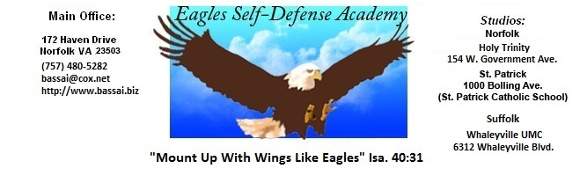

LEGEND: P+ = EXCEPTIONAL, P = ABOVE AVERAGE, P- = BELOW AVERAGE

EAGLES NAME:
SELF-DEFENSE ACADEMY DATE: BELT SIZE: ____
INSTRUCTOR:

Adult Gold
Junior Purple
Belt Test Requirements

REMARKS
I HOUR REQUIREMENTS: 15-25 HOURS MINIMUM
II CLEAN UNIFORM WITH SCHOOL PATCH, FLAG
& PROPERLY TIED BELT
III TERMS
A. Karate (Car Ah Tea) - Empty hand
B. Tang Soo Do (Tah_ng Sue Doe) - Art of the hands
C. Charyut (Carry Ut) - Attention
D. Kyung Ne (Key_Young Knee) - Bow
E. Toe Bok (Toe Bok) - Karate Uniform
F. Jun Bi (June Bye) - Ready Stance
G. Parro (Par Oh) - Return to Ready Stance
H. Sho (Show) - Relax

IV STANCES
A. Ready Stance D. Forward Stance
B. Straddle Leg Stance E. Side Stance
C. Back Stance

V PUNCHES, HAND STRIKES & ELBOWS
A. High E. Jab (From Back Stance)
B. Center F. Reverse Punch with Full Hip Action
C. Low G..Elbow Strikes (6)
D. Open Hand Strikes (4)
VI BLOCKS
BACK STANCE REVERSE PUNCH
A. Knifehand A. Knifehand
B. Low B. Low
C. High C. High

VII FALLS AND ROLLS
A. Forward Fall C. Forward Shoulder Roll
B. Backward Fall

VIII STEPPING PUNCHES
A. High D. Reverse
B. Center E. Jab
C. Low

IX KICKS
A. Standing Front A. Slide-up Front A. Stepping Front
B. Standing Round B. Slide-up Round
C. Standing Back

X SELF DEFENSE
A. Choke Hold C. Footsweep
B. Two Hand Wrist Grab D. Side Grab

XI FORMS
A. Basic Form #1 Geicho Hyung Il Bu

XII ATTITUDE

